

2014-2015

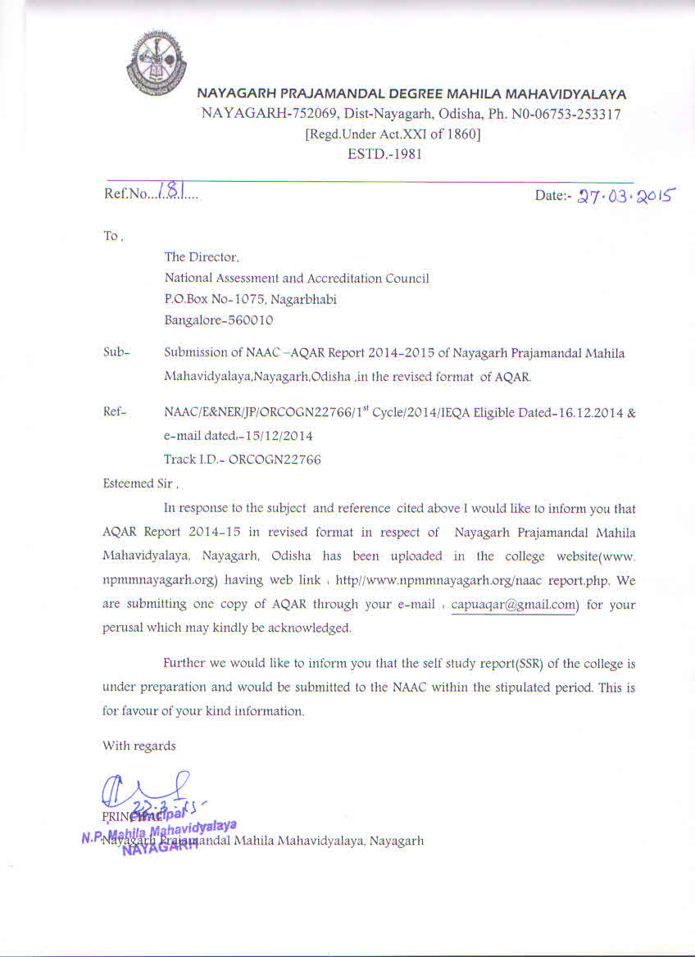

# *The Annual Quality Assurance Report (AQAR) of the IQAC*

Part – A

2014-2015

**AQAR for the year *(for example 2013-14)***

**1. Details of the Institution**

NAYAGARH PRAJAMANDAL MAHILA MAHAVIDYALAYA , NAYAGARH

Maha

1.1 Name of the Institution

NAYAGARH

1.2 Address Line 1

NAYAGARH

Address Line 2

NAYAGARH

City/Town

State

ODISHA

752069

Pin Code

info@npmmnayagarh.org

Institution e-mail address

06753-253317

Contact Nos.

Mr. Shreedhar Khuntia

Name of the Head of the Institution:

06753-253317

Tel. No. with STD Code:

Mobile:

09938715336

Dr. Krupasindhu Karan.

Name of the IQAC Co-Ordinator:

Mobile:

09938938278

nayagarhnpmm iqac@gmail.com

IQAC e-mail address:

**ORCOGN 22766**

1.3 **NAAC Track ID** *(For ex. MHCOGN 18879)*

**OR**

1.4 **NAAC Executive Committee No. & Date:**

*(For Example EC/32/A&A/143 dated 3-5-2004.*

*This EC no. is available in the right corner- bottom*

*of your institution’s Accreditation Certificate)*

www.npmmnayagarh.org

1.5 Website address:

http://www. npmmnayagarh.org/naac.report.php

Web-link of the AQAR:

For ex. http://www.ladykeanecollege.edu.in/AQAR2012-13.doc

1.6 Accreditation Details

|  |
| --- |
| Applied for 1st Cycle of NAAC Accreditation  ORCOGN 22766 |

**18.07.2011**

1.7 Date of Establishment of IQAC :

DD/MM/YYYY

1.8 Details of the previous year’s AQAR submitted to NAACafterthe latest Assessment and

Accreditation by NAAC (*(for example AQAR 2010-11submitted to NAAC on 12-10-2011)*

1. AQAR _____2014-2015__________________ (27/03/2015)
2. AQAR__________________ ________________________ (DD/MM/YYYY)
3. AQAR__________________ _______________________ (DD/MM/YYYY)
4. AQAR__________________ _______________________ (DD/MM/YYYY)

1.9 Institutional Status

University State Central Deemed Private

**√**

Y

Affiliated College Yes No

Constituent College Yes No

√

N√

Autonomous college of UGC Yes No

√

√

Regulatory Agency approved Institution Yes No

(eg. AICTE, BCI, MCI, PCI, NCI)

√

Type of Institution Co-education Men Women

√

Urban Rural Tribal

√

√

√

Financial Status Grant-in-aid UGC 2(f) UGC 12B Y

Grant-in-aid + Self Financing Totally Self-financing

1.10 Type of Faculty/Programme

Arts Science Commerce Law PEI (Phys Edu)

√

TEI (Edu) Engineering Health Science Management



Others (Specify)

1.11 Name of the Affiliating University *(for the Colleges)*

UTKAL UNIVERSITY (ODISHA)

1.12 Special status conferred by Central/ State Government-- UGC/CSIR/DST/DBT/ICMR etc

Autonomy by State/Central Govt. / University

University with Potential for Excellence UGC-CPE

DST Star Scheme UGC-CE

UGC-Special Assistance Programme DST-FIST

UGC-Innovative PG programmes Any other (*Specify*)

UGC-COP Programmes

**2. IQAC Composition and Activities**

07

2.1 No. of Teachers

01

2.2 No. of Administrative/Technical staff

01

2.3 No. of students

2.4 No. of Management representatives

01

00

2.5 No. of Alumni

2. 6 No. of any other stakeholder and

00

community representatives

00

2.7 No. of Employers/ Industrialists

02

2.8 No. of other External Experts

2.9 Total No. of members

12

04

2.10 No. of IQAC meetings held

Faculty

07

03

2.11 No. of meetings with various stakeholders:

00

02

02

Non-Teaching Staff Students Alumni Others

2.12 Has IQAC received any funding from UGC during the year? Yes No

√

RS.-3, 00,000.00

If yes, mention the amount

2.13Seminars and Conferences (only quality related)

(i) No. Of Seminars/Conferences/ Workshops/Symposia organized by the IQAC

02

22

Total Nos. International National State Institution Level

NAAC Criterion –II & Positive attitude

(ii) Themes

2.14 Significant Activities and contributions made by IQAC

The institution strives to build thriving learning culture and to become an acceptable educational institution which shall always promote pursuit of excellence and inculcation of human values. The mission of the college is for all-round holistic development of the students. To fulfil this aim a number of activities were undertaken for academic, cultural and skill development of the students. Plans were undertaken for sustaining excellence in teaching and learning. Steps were taken to strengthen library service and to make it more user friendly .Emphasis was given in academic class seminars and initiatives to make the teaching learning process more hi-tech. Various special days were celebrated to enlighten the students. Courses like Computer Literacy and Communicative English were introduced. New website of college was launched with integration of online automation software. Library was equipped with internet facilities, audio-video library, book bank facility, and computerized information service for students. Internet cafe was made available in the computer lab. Street plays, rallies were organized to create awareness against social evils and superstitions like illiteracy, dowry problem, witch-craft, domestic violence against women, and early marriage of girls. The institute also extends its tiny hand to support the global mission to generate awareness against Climate Change and environmental pollution. Various literary competitions and cultural programmes were organized round the year to enhance talent and skills among students. The activities of various associations were extended. Besides these steps also were undertaken for infrastructure development which includes students’ common room, seminar hall and class room for each department, administrative building, and separate reading room for staff and students. Steps were undertaken to provide safe drinking water.

2.15 Plan of Action by IQAC/Outcome

The plan of action chalked out by the IQAC in the beginning of the year towards quality enhancement and the outcome achieved by the end of the year *

|  |  |
| --- | --- |
| Plan of Action | Achievements |
| * To encourage teachers to attend /conduct UGC sponsored State and National Level seminars, conference and workshops. * To encourage the teachers and students to organize departmental academic seminars. * To join refresher courses under UGC programme. * To encourage students to participate in social activities through NSS/YRC/RRC wings of the college. * To encourage the teachers to go for computer operation training to make them computer literate and enable them to use computer & internet in the teaching learning process. * To encourage the students for more participations in games & sports conducted by the colleges and University. * To encourage the faculty members to apply for UGC funded minor /major research projects. * To conduct various cultural and academic competitions among the students. * To organize talks by different career counselling organization to motivate the students for higher study after completion their degree. | * Seminar Hall , three Class Rooms & One Computer Laboratory was completed. * Five rooms were provided with Power Point facility. * Departmental academic seminars were organized. * New website. (www.npmmnayagarh.org) was lunched with integration of online office automation (Library, Accounts, Establishments, Examination & Admission.) * Library reformation was undertaken, (e-library, A/V library, Internet cafe, Computerized student information service Book Bank facility, Reprography facility, Staff reading room etc.) * New courses such as Computer Literacy and Communicative English were introduced. * Skill development and Personality development programmes were conducted by career counselling cell. * The Y.R.C unit of the college organized Voluntary Blood Grouping Camp, Awareness Programmes and seminars on Social issues. * The N.S.S unit of the college organized special camps and celebrated National Days of importance. * Alumni and Parent – Teacher Association meetings were conducted. * Expert talks and remedial classes were arranged. * ICT equipments, Computers, Laptops; Projector, Smart Board and Printer were availed from UGC Additional Grants. * Books were purchased and Journals were subscribed from UGC Grant. |

**(Holiday list for the session 2014-15 Copy Attached Annexure –I )**

√

r

2.15 Whether the AQAR was placed in statutory body Yes No

Management Syndicate Any other body

Provide the details of the action taken

Part – B

**Criterion – I**

**1. Curricular Aspects**

1.1 Details about Academic Programmes

|  |  |  |  |  |
| --- | --- | --- | --- | --- |
| Level of the Programme | Number of existing Programmes | Number of programmes added during the year | Number of self-financing programmes | Number of value added / Career Oriented programmes |
| PhD |  |  |  |  |
| PG |  |  |  |  |
| UG | 01 |  |  |  |
| PG Diploma |  |  |  |  |
| Advanced Diploma |  |  |  |  |
| Diploma |  |  |  |  |
| Certificate |  |  |  |  |
| Others |  |  |  |  |
| **Total** | 01 |  |  |  |

|  |  |  |  |  |
| --- | --- | --- | --- | --- |
| Interdisciplinary |  |  |  |  |
| Innovative |  |  |  |  |

1.2 (i) Flexibility of the Curriculum: CBCS/Core/Elective option / **Open options**

(ii) Pattern of programmes:

|  |  |
| --- | --- |
| Pattern | Number of programmes |
| Semester | 00 |  |  |  |
| Trimester | 00 |
| Annual | **03** |

√

√

√

√

1.3 Feedback from stakeholders* Alumni Parents Employers Students

***(On all aspects)***

√

Mode of feedback : Online Manual Co-operating schools (for PEI)

***\*Please provide an analysis of the feedback in the Annexure***

1.4 Whether there is any revision/update of regulation or syllabi, if yes, mention their salient aspects.

University revises and updates from time to time

1.5 Any new Department/Centre introduced during the year. If yes, give details.

No

**Criterion – II**

**2. Teaching, Learning and Evaluation**

|  |  |  |  |  |
| --- | --- | --- | --- | --- |
| Total | Asst. Professors | Associate Professors | Professors | Others |
| 24 | 22 | 02 |  |  |

2.1 Total No. of permanent faculty

03

2.2 No. of permanent faculty with Ph.D.

|  |  |  |  |  |  |  |  |  |  |
| --- | --- | --- | --- | --- | --- | --- | --- | --- | --- |
| Asst. Professors | | Associate Professors | | Professors | | Others | | Total | |
| R | V | R | V | R | V | R | V | R | V |
| - | 04 | - |  |  |  |  |  | - | 04 |

2.3 No. of Faculty Positions Recruited (R) and Vacant (V) during the year

03

2.4 No. of Guest and Visiting faculty and Temporary faculty

2.5 Faculty participation in conferences and symposia:

|  |  |  |  |
| --- | --- | --- | --- |
| No. of Faculty | International level | National level | State level |
| Attended Seminars/ Workshops | 02 |  |  |
| Presented papers |  | 04 |  |
| Resource Persons |  |  | 06 |

2.6 Innovative processes adopted by the institution in Teaching and Learning:

* Use of power point
* Group Discussion
* Quiz , Debate& Essay Competitions
* Expert Talk

180

2.7 Total No. of actual teaching days

during this academic year

2.8 Examination/ Evaluation Reforms initiated by

the Institution (for example: Open Book Examination, Bar Coding,

Double Valuation, Photocopy, Online Multiple Choice Questions)

Test Examination . Monthly Test for Hons. Students. Photo copy of valued answer scripts , Revaluation , Examination conducted as per University Rules

03

2.9 No. of faculty members involved in curriculum

restructuring/revision/syllabus development

as member of Board of Study/Faculty/Curriculum Development workshop

2.10 Average percentage of attendance of students

75%

2.11 Course/Programme wise

distribution of pass percentage :

|  |  |  |  |  |  |  |
| --- | --- | --- | --- | --- | --- | --- |
| Title of the Programme | Total no. Of students appeared  ( 2013-14) | Division | | | | |
| Distinction % | I % | II % | III % | Pass % |
| B.A. (+3) Hons , | 83 | 8.43 | 26.5 | 46.98 | 3.6 | 77 |
| B.A. (+3)Pass | 25 | 4 | - | - | - | 64 |

2.12 How does IQAC Contribute/Monitor/Evaluate the Teaching & Learning processes :

IQAC members interact and cooperate with teachers to bring excellence in teaching and learning process, provides information regarding various academic activities , keeps record of participation .

2.13 Initiatives undertaken towards faculty development

|  |  |
| --- | --- |
| *Faculty / Staff Development Programmes* | *Number of faculty benefitted* |
| Refresher courses | 02 |
| UGC – Faculty Improvement Programme |  |
| HRD programmes |  |
| Orientation programmes |  |
| Faculty exchange programme |  |
| Staff training conducted by the university |  |
| Staff training conducted by other institutions |  |
| Summer / Winter schools, Workshops, etc. |  |
| Others |  |

2.14 Details of Administrative and Technical staff

|  |  |  |  |  |
| --- | --- | --- | --- | --- |
| Category | Number of Permanent  Employees | Number of Vacant  Positions | Number of permanent positions filled during the Year | Number of positions filled temporarily |
| Administrative Staff | 16 | 04 | - | - |
| Technical Staff | 01 | - | - | - |

**Criterion – III**

**3. Research, Consultancy and Extension**

3.1 Initiatives of the IQAC in Sensitizing/Promoting Research Climate in the institution

IQAC of the college takes initiative to encourage and help in applying Minor Research Projects to UGC and other Funding Agencies . It also guides the staff in preparation of Synopsis and thesis .

3.2Details regarding major projects

|  |  |  |  |  |
| --- | --- | --- | --- | --- |
|  | Completed | Ongoing | Sanctioned | Submitted |
| Number | - | - | - | - |
| Outlay in Rs. Lakhs | - | - | - | - |

3.3 Details regarding minor projects

|  |  |  |  |  |
| --- | --- | --- | --- | --- |
|  | Completed | Ongoing | Sanctioned | Submitted |
| Number | - | - | - | - |
| Outlay in Rs. Lakhs | - | - | - | - |

3.4 Details on research publications

|  |  |  |  |
| --- | --- | --- | --- |
|  | International | National | Others |
| Peer Review Journals |  |  |  |
| Non-Peer Review Journals |  |  |  |
| e-Journals |  |  |  |
| Conference proceedings |  |  |  |

3.5 Details on Impact factor of publications:

Range Average h-index Nos. in SCOPUS

3.6 Research funds sanctioned and received from various funding agencies, industry and other organisations

|  |  |  |  |  |
| --- | --- | --- | --- | --- |
| Nature of the Project | Duration  Year | Name of the  funding Agency | Total grant  sanctioned | Received |
| Major projects |  |  |  |  |
| Minor Projects |  |  |  |  |
| Interdisciplinary Projects |  |  |  |  |
| Industry sponsored |  |  |  |  |
| Projects sponsored by the University/ College |  |  |  |  |
| Students research projects  *(other than compulsory by the University)* |  |  |  |  |
| Any other(Specify) |  |  |  |  |
| Total |  |  |  |  |

3.7 No. of books published i) With ISBN No. Chapters in Edited Books

01

ii) Without ISBN No.

3.8 No. of University Departments receiving funds from

UGC-SAP CAS DST-FIST

DPE DBT Scheme/funds

3.9 For colleges Autonomy CPE DBT Star Scheme

INSPIRE CE Any Other (specify)

-

3.10 Revenue generated through consultancy

|  |  |  |  |  |  |
| --- | --- | --- | --- | --- | --- |
| Level | International | National | State | University | College |
| Number |  | 01  (Sanctioned) |  |  |  |
| Sponsoring agencies |  | UGC |  |  |  |

3.11 No. of conferences

organized by the Institution

05

3.12 No. of faculty served as experts, chairpersons or resource persons

3.13 No. of collaborations International National Any other

3.14 No. Of linkages created during this year

3.15 Total budget for research for current year in lakhs :

-

-

From Funding agency From Management of University/College

Total

-

|  |  |  |
| --- | --- | --- |
| Type of Patent |  | Number |
| National | Applied | - |
| Granted | - |
| International | Applied | - |
| Granted | - |
| Commercialised | Applied | - |
| Granted | - |

3.16 No. of patents received this year

3.17 No. of research awards/ recognitions received by faculty and research fellows

|  |  |  |  |  |  |  |
| --- | --- | --- | --- | --- | --- | --- |
| Total | International | National | State | University | Dist | College |
|  |  |  |  |  |  |  |

Of the institute in the year

3.18 No. of faculty from the Institution

-

who are Ph. D. Guides

and students registered under them

-

3.19 No. of Ph.D. awarded by faculty from the Institution

-

3.20 No. of Research scholars receiving the Fellowships (Newly enrolled + existing ones)

JRF SRF Project Fellows Any other

3.21 No. of students Participated in NSS events:

University level State level

National level International level

3.22 No. of students participated in NCC events:

University level State level

National level International level

3.23 No. of Awards won in NSS:

University level State level

National level International level

3.24 No. of Awards won in NCC:

University level State level

National level International level

3.25 No. of Extension activities organized

05

-

University forum College forum

-

--

NCC NSS Any other

* 1. Major Activities during the year in the sphere of extension activities and Institutional Social Responsibility
* Blood Grouping Camp .
* Formation of Red Ribbon Club in nearby village .
* Awareness on personal hygiene among village women .
* Campaign against Female Foeticide and Early marriage .
* Awareness on Women Literacy among village women .

**Criterion – IV**

**4. Infrastructure and Learning Resources**

4.1 Details of increase in infrastructure facilities:

|  |  |  |  |  |
| --- | --- | --- | --- | --- |
| Facilities | Existing | Newly created | Source of Fund | Total |
| Campus area | 5.77 acre | - |  | 5.77 acre |
| Class rooms | 6,625 Sq.ft | 1213 Sq.ft | State Govt & College fund | 7,838 Sq.ft |
| Laboratories | 738 Sq.ft | 624 Sq.ft | Stat Govt & College fund | 1362 Sq.ft |
| Seminar Halls | -- | 1833 Sq.ft | State Govt. | 1833 Sq.ft |
| No. of important equipments purchased (≥ 1-0 lakh) during the current year. | 816 | 27 | - | 843 |
| Value of the equipment purchased during the year (Rs. in Lakhs) | 2,54,448 | 3,86,000 | UGC & College fund | 6,40,448 |
| Others |  |  |  |  |

4.2 Computerization of administration and library

Administrative section and Library were equipped with online software developed.

4.3 Library services:

|  |  |  |  |  |  |  |
| --- | --- | --- | --- | --- | --- | --- |
|  | Existing | | Newly added | | Total | |
| No. | Value | No. | Value | No. | Value |
| Text Books | 3,533 | 2,52,790 | 364 | 39,600. | 3,877 | 2,92,390 |
| Reference Books | 9,044 | 8,48,074 | 485 | 83,477. | 9,529 | 9,31,551 |
| e-Books | - | - | - | - | - | - |
| Journals | - |  | 11 | 15,500 | 11 | 15,500 |
| e-Journals | - | - | - | - | - | - |
| Digital Database | - | - | - | - | - | - |
| CD & Video | - | - | - | - | - | - |
| Others (specify) | - | - | - | - | - | - |

4.4 Technology up gradation (overall)

|  |  |  |  |  |  |  |  |  |
| --- | --- | --- | --- | --- | --- | --- | --- | --- |
|  | Total Computers | Computer Labs | Internet | Browsing Centres | Computer Centres | Office | Depart-ments | Others |
| Existing | 15 | 04 | 02 |  |  | 04 | 03 | 02 |
| Added | 35 | 30 | 02 |  |  |  |  | 03 |
| Total | 50 | 34 | 04 |  |  | 04 | 03 | 05 |

4.5 Computer, Internet access, training to teachers and students and any other programme for technology

Up gradation (Networking, e-Governance etc.)

1. Internet facility is provided to library and individual departments.
2. INFLIBNET N-list facility subscribed for all Teaching & Non Teaching staff.
3. Computerization of library completed.
4. Xerox machine provided to the library.
5. Course in computer literary and Communicative English classes are introduced.

4.6 Amount spent on maintenance in lakhs :

0.23

i) ICT

1.9

ii) Campus Infrastructure and facilities

0.42

iii) Equipments

4.1

iv) Others

6.65

**Total :**

**Criterion – V**

**5. Student Support and Progression**

5.1 Contribution of IQAC in enhancing awareness about Student Support Services

Reprographic facility , Safe Drinking Water , Student’s Common Room, Subscription of Magazines, Internet , e-journals , Books , Newspaper, canteen.

5.2 Efforts made by the institution for tracking the progression

Career counselling cell, Placement cell, Spoken English, Self Defence Training , Medical check-up, Competitions ,Study tours , Personality development through various activities.

|  |  |  |  |
| --- | --- | --- | --- |
| UG | PG | Ph. D. | Others |
| 643 | - | - | - |

5.3 (a) Total Number of students

(b) No. of students outside the state

--

--

(c) No. of international students

|  |  |
| --- | --- |
| No | % |
|  |  |

|  |  |
| --- | --- |
| No | % |
|  |  |

Men Women

|  |  |  |  |  |  |  |  |  |  |  |  |
| --- | --- | --- | --- | --- | --- | --- | --- | --- | --- | --- | --- |
| Last Year- 2013-2014 | | | | | | This Year-2014-2015 | | | | | |
| General | SC | ST | OBC | Physically Challenged | Total | General | SC | ST | OBC | Physically Challenged | Total |
| 104 | 18 | 14 | 361 | - | 497 | 127 | 22 | 14 | 480 | 02 | 643 |

Demand ratio 1: 2.5 Dropout % **00**

5.4 Details of student support mechanism for coaching for competitive examinations (If any)

Computer Lab, Internet.LCD, Printed materials , Materials on entry in services.

No. of students beneficiaries

5.5 No. of students qualified in these examinations

NET SET/SLET GATE CAT

IAS/IPS etc State PSC UPSC Others

5.6 Details of student counselling and career guidance

About 100 students were given guidance through different academic agencies running in the state and counselling of students has been done.

100

No. of students benefitted

5.7 Details of campus placement

|  |  |  |  |
| --- | --- | --- | --- |
| ***On campus*** | | | ***Off Campus*** |
| Number of Organizations Visited | Number of Students Participated | Number of Students Placed | Number of Students Placed |
|  |  |  |  |
|  |  |  |  |
|  |  |  |  |

5.8 Details of gender sensitization programmes

Health cheek up, Self Defence Training for Girl Students, Personality Development , Lectures on social and Legal issues relating to women , Active Citizenship Programme . establishment of sexual harassment cell

5.9 Students Activities

5.9.1 No. of students participated in Sports, Games and other events

State/ University level National level International level

No. of students participated in cultural events

State/ University level National level International level

5.9.2 No. of medals /awards won by students in Sports, Games and other events Sports :

State/ University level National level International level

Cultural: State/ University level National level International level

5.10 Scholarships and Financial Support

|  |  |  |
| --- | --- | --- |
|  | Number of  students | Amount |
| Financial support from institution | - | - |
| Financial support from government | 20 | 1,05,600 |
| Financial support from other sources | - | - |
| Number of students who received International/ National recognitions | - | - |

5.11 Student organised / initiatives

Fairs : State/ University level National level International level

Exhibition: State/ University level National level International level

08

5.12 No. of social initiatives undertaken by the students

5.13 Major grievances of students (if any) redressed:

* Facility of Reading Room in Library
* Renovation of College Canteen
* Additional Lavatories

**Criterion – VI**

**6. Governance, Leadership and Management**

**6.1 State the Vision and Mission of the institution**

**Vision –** This college is a Primer Women institution catering to the higher education aspiration of both socially, educationally ,economically backward and minority women of Nayagharh District of Odisha. Though situated in an urban locality, the students hail from remote areas of nearby districts of Boudh, Kandhamal, Ganjam, Khurdha,Cuttack etc. The college has completed 34 years of existence. The institution strives to build thriving learning culture and to become an acceptable educational institution which shall always promote pursuit of excellence and inculcation of human values.

* The vision of the institution is to provide the opportunity of higher education to the girl students of the locality at an affordable price.
* To provide quality education to the students and to make their acquired knowledge, skill, and qualification more relevant to global needs.
* It is also the vision of the institution to make higher education accessible to various groups of the society particularly the girls belonging to economically weaker section, hilly, backward, inaccessible and minority community.
* To build a developed, enlightened, tolerant & progressive society through improvement of knowledge.

**Mission –**

* To establish an equitable society through women empowerment and communal harmony.
* To impart quality education ,learning and research.
* To empower students with professional competency to meet global challenges.
* To inculcated the habit of continual learning, the spirit of compassion and human values in students.
* To nourish the quality of leadership, entrepreneurship invention and ethics.
* To create an outstanding ambiance of academic and intellectual pursuit and physical activities.
* To create an environment of intellectual stimulus in scientific inquiry and responsibility.
* To promote economic and community development through inculcation of productive partnership.
* To equip the residential campus with all basic amenities and fulfil the nutritional need and safety of the students.

6.2 Does the Institution has a Management Information System - No

6.3 Quality improvement strategies adopted by the institution for each of the following:

6.3.1 Curriculum Development

As guided by Utkal University Vanivihar Bhubaneswar, Odisha

6.3.2 Teaching and Learning

Extra coaching to advanced Learners, Internet facility provided to staff and students ,teaching through power point presentation implemented , Group Discussion , ICT Videos

6.3.3 Examination and Evaluation

Monthly Tests, Test Examinations are regularly held . Facility for Xerox copy of valued answer scripts.

6.3.4 Research and Development

Some MRP proposals are submitted to UGC

6.3.5 Library, ICT and physical infrastructure / instrumentation

Adequate numbers of text books and reference books are purchased for departmental seminar library, Display cupboard for each department.

6.3.6 Human Resource Management

Different Committees are framed to execute and monitor the development in academic , administrative and developmental activities of the college

6.3.7 Faculty and Staff recruitment

Nil

No

6.3.8 Industry Interaction / Collaboration

6.3.9 Admission of Students

Admission Process is controlled by D.H.E, Odisha, through SAMS (Students Academic Management System)

|  |  |
| --- | --- |
| Teaching | GPF. GIS, EPF |
| Non teaching | GPF, GIS, EPF |
| Students |  |

6.4 Welfare schemes for

Nil

6.5 Total corpus fund generated

√

6.6 Whether annual financial audit has been done Yes No

6.7 Whether Academic and Administrative Audit (AAA) has been done?

|  |  |  |  |  |
| --- | --- | --- | --- | --- |
| Audit Type | External | | Internal | |
| Yes/No | Agency | Yes/No | Authority |
| Academic | Yes | DLC  ( state govt ) | Yes |  |
| Administrative | Yes | DLC  ( state govt | Yes |  |

6.8 Does the University/ Autonomous College declare results within 30 days?

For UG Programmes Yes No

For PG Programmes Yes No

6.9 What efforts are made by the University/ Autonomous College for Examination Reforms?

N.A.

6.10 What efforts are made by the University to promote autonomy in the affiliated/constituent colleges?

N.A.

6.11 Activities and support from the Alumni Association

Alumni Association meetings are held on where different issues pertaining to development of the college are discussed and they extend this helping hand in different activity of the college.

6.12 Activities and support from the Parent – Teacher Association

P.T.A. meeting are held and their feedbacks are given due importance.

6.13 Development programmes for support staff

Nil

6.14 Initiatives taken by the institution to make the campus eco-friendly

Tobacco free Campus, Plantation Drive, Use of CFL and LED lamps, Use of polythene banned establishment of eco-club to make students aware

**Criterion – VII**

**7. Innovations and Best Practices**

7.1 Innovations introduced during this academic year which have created a positive impact on the

functioning of the institution. Give details.

Computers were provided to four departments with internet facility. New website was launched with integrated library and office automation software.

7.2 Provide the Action Taken Report (ATR) based on the plan of action decided upon at the

beginning of the year

7.3 Give two Best Practices of the institution *(please see the format in the NAAC Self-study Manuals)*

Emphasis on Women Empowerment

Adoption of modern technology for teaching and learning

***\*Provide the details in annexure (annexure need to be numbered as i, ii,iii)***

7.4 Contribution to environmental awareness / protection

Campus cleanliness programme, Tobacco free Campus, Plantation Drive , Use of CFL and LED lamps , Use of polythene banned , Establishment of eco-club to make students aware

No

√

7.5 Whether environmental audit was conducted? Yes No

7.6 Any other relevant information the institution wishes to add. (for example SWOT Analysis)

Nil

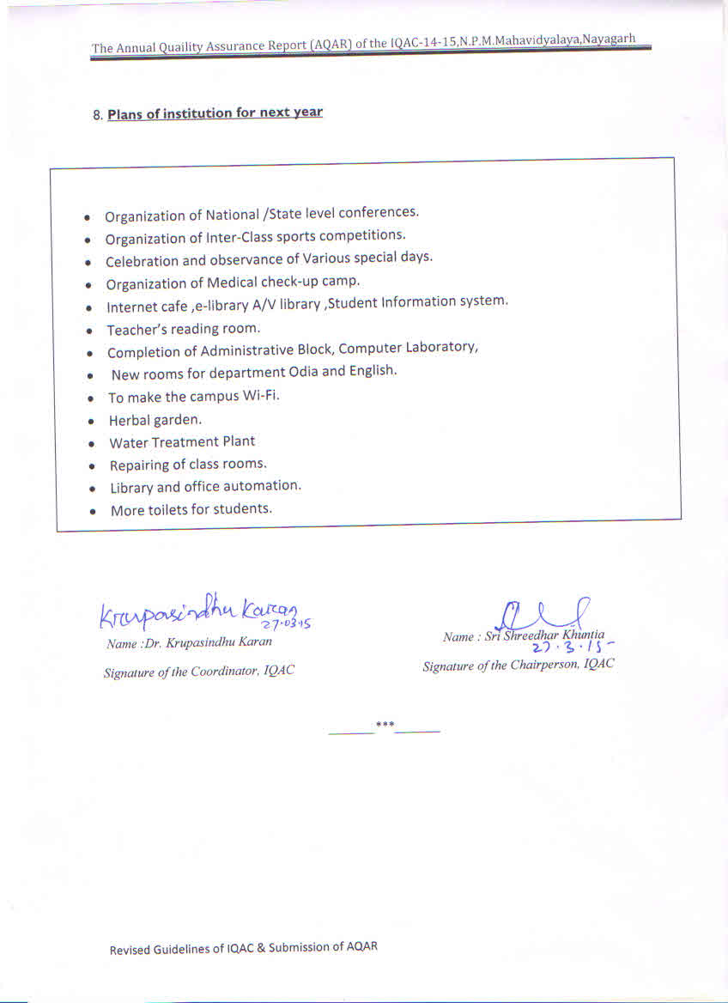

**Annexure I**

**NAYAGARH PRAJAMANDAL MAHILA MAHAVIDYALAYA, NAYAGARH**

**LIST OF HOLIDAYS 2015**

**No. Dt.**

|  |  |  |  |  |
| --- | --- | --- | --- | --- |
| **Sl.No** | **Occasion** | **Date** | **Days** | **No. of days** |
| **01** | **Bahuda Yatra** | **07.07.2014** | **Monday** | **01** |
| **02** | **Chitalagi Amabasya** | **26.07.14** | **Saturday** | **01** |
| **03** | **Idul-fitre** | **29.07.14** | **Tuesday** | **01** |
| **04** | **Nanda Utchhaba** | **18.08.2014** | **Monday** | **01** |
| **05** | **Nuakhai** | **30.08.14** | **Saturday** | **01** |
| **06** | **Sudasa Brata** | **04.09.2014** | **Thursday** | **01** |
| **07** | **Mahalaya** | **23.09.2014** | **Tuesday** | **01** |
| **08** | **Duti Baman Osha** | **26.09.2014** | **Tuesday** | **01** |
| **09** | **Puja Vacation** | **01.10.2014 To 09.10.2014** | **Wednesday to Thursday** | **08** |
| **10** | **Diwali** | **23.10.2014** | **Thursday** | **01** |
| **11** | **Kali Puja** | **24.10.2014** | **Friday** | **01** |
| **12** | **Maharam** | **04.11.2014** | **Tuesday** | **01** |
| **13** | **Bada osha** | **05.11.2014** | **Wednesday** | **01** |
| **14** | **Rasa Purnima & Chhadakhai** | **06.11.2014 & 07.11.2014** | **Thursday & Friday** | **02** |
| **15** | **Prathamastami** | **15.11.2014** | **Saturday** | **01** |
| **16** | ***Laxmi puja*** | ***04.12.2014*** | ***Thursday*** | ***01*** |
| **17** | **“X” - Mas Day** | **25.12.2014** | **Thursday** | **01** |
| **18** | **New Years Day** | **01.01.2015** | **Thursday** | **01** |
| **19** | **Makar Sankranti** | **14.01.2015** | **Wednesday** | **01** |
| **20** | **Netaji Jayanti** | **23.01.2015** | **Friday** | **01** |
| **21** | **Saraswati Puja** | **24.01.2015** | **Saturday** | **01** |
| **22** | **Republic Day** | **26.01.2015** | **Monday** | **01** |
| **23** | ***Sudasabrata*** | ***29.01.2015 (Reserve Holiday)*** | **Thursday** | **01** |
| **24** | **Mahasivaratri** | **17.02.2015** | **Tuesday** | **01** |
| **25** | **Panchayat Raj Divas & Dola Purnima** | **05.03.2015** | **Thursday** | **01** |
| **26** | **Holi** | **06.03.2015** | **Friday** | **01** |
| **27** | **Shree Ram Navami** | **28.03.2015** | **Saturday** | **01** |
| **28** | **Utkal Divas** | **01.04.2015** | **Wednesday** | **01** |
| **29** | **Good Friday** | **03.04.2015** | **Friday** | **01** |
| **30** | **Maha Visuva Sankranti/ Dr.B.R Ambedkar Jayanti )** | **14.04.2015** | **Tuesday** | **01** |
| **31** | **Summer Vacation** | **11.05.2015 to18.06.2015** | **Monday To Thursday** | **34** |
|  |  | **Number Of Holidays** | | **72** |